Taituarā FrankGroup Award for Excellence in Community Engagement
Project Summary
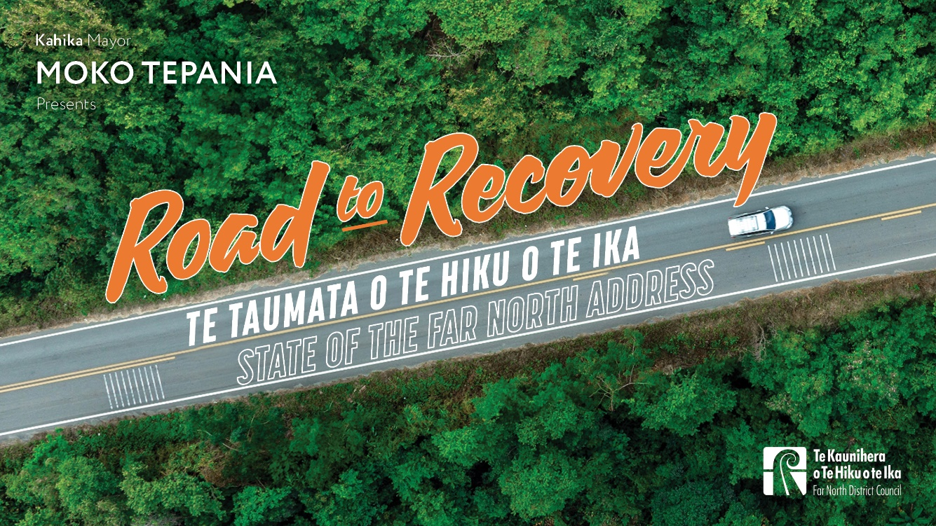The State of the Far North Address was an innovative event designed to activate better engagement, shift perceptions, and strengthen relationships between the council and the community. Gathering over 200 leaders from Te Ao Māori, business, politics, and the wider public, the event acted as a new channel for direct and transparent communication. Mayor Moko Tepania delivered a compelling presentation addressing challenges faced by the district and outlining recovery efforts by the council. The event successfully changed the narrative about the council demonstrating bold leadership in local government. Due to its success, this initiative will now be held annually as a key engagement tool for the district.
Strategic Context
The Far North District has faced extraordinary challenges since 2020 including severe drought, a post-COVID economic downturn, and 10 major weather events between 2022 and 2023. These events led to 487 road slips and a $41 million repair bill. Despite increased council communications, public satisfaction with the council’s overall performance dropped from 26% in 2022 to 18% in 2024. Like many government agencies, we have also detected increased online hostility towards staff, elected members and the organisation. This indicated the need for a new approach. The State of the Far North Address was created to reset the conversation, discuss challenges, highlight recovery efforts, and strengthen partnerships with our communities.
Unlike traditional council reports, the State of the Far North Address combined strategic storytelling, cultural inclusivity, and direct engagement to deliver an impactful and memorable event. The success of this approach became evident in significantly improved public sentiment, increased engagement, and a strengthened sense of partnership between the council and community. The address also reaffirmed the council’s accountability and responsibility to residents through clear explanations of policy decisions to allow stakeholders to hold the council accountable for outlined initiatives. This structured format will ensure progress can be tracked year-on-year, fostering a deeper level of trust and ongoing dialogue between council and the community.
The goals of State of the Far North Address align with our strategic direction which sets out our vision, mission, purpose, strategic goals and our six strategic priorities. The core values of integrity, manaakitanga and professionalism – which are the foundation of this strategic direction – were key drivers of the tone, content and style of the presentation.
- Integrity - trust, honesty, transparency, reliability, ethical, fairness, openness
- Manaakitanga - teamwork, empowerment, empathy, awhina, unity, supportive, courtesy, respect
- Professionalism - consistency, tikanga, motivation, ownership, positivity, innovation, collaborative.
The format was designed to encourage and strengthen relationship-building. Face to face attendance was the priority, but the event was also filmed to ensure engagement with an extended online audience after the event. The full presentation as well as selected highlights were made available on digital platforms, including YouTube and social media. This broad distribution of key messages and shared insights, enabled the council’s vision to reach residents who were unable to attend in person.
Media engagement was also critical to ensuring the presentation’s key messages reached wider audiences. A dedicated session immediately following the main presentation ensured journalists could easily capture this content.
Project Management
Scope: Our key audience of community leaders were all personally invited by the mayor. This targeted approach ensured those who influence the district’s future were in the room alongside the general public, reinforcing council’s commitment to accessibility and transparency.
Outside the formal presentation, the event incorporated a dedicated networking opportunity before and after the address. This allowed attendees from diverse backgrounds to interact, discuss issues, and establish connections with council representatives and each other. Creating an environment where community leaders could interact freely encouraged meaningful dialogue, facilitated partnerships, and strengthened community engagement beyond the event itself. The networking sessions also reinforced the address as a platform for ongoing collaboration and relationship-building.
Timeframes: The Communications and Engagement team began planning and scripting the address in late July. Two months ahead, the event was ‘teased’ via news stories on the FNDC website, which were shared on social media. Further releases detailed RSVPs required to reserve a ticket, as well as countdowns to the 12 November event from mid-October onwards.
Resources: All development and planning was undertaken in-house with staff volunteers managing the event on the night. The exceptions were catering, security, kapa haka performers and some venue staff. Total expenses were no more than $15,000.
Quality assurance systems: Multiple data points were used to measure the success of the event including post-event surveys, media coverage, social media engagement, and audience reach. Feedback from attendees was overwhelmingly positive, with post-event surveys indicating that 82% of respondents were more confident in the council’s approach to governance. Media coverage was also positive. RNZ described it as “a groundbreaking approach to local government transparency”. Te Ao News noted “the integration of tikanga throughout the address demonstrated a commitment to genuine collaboration”.
Relationship Management
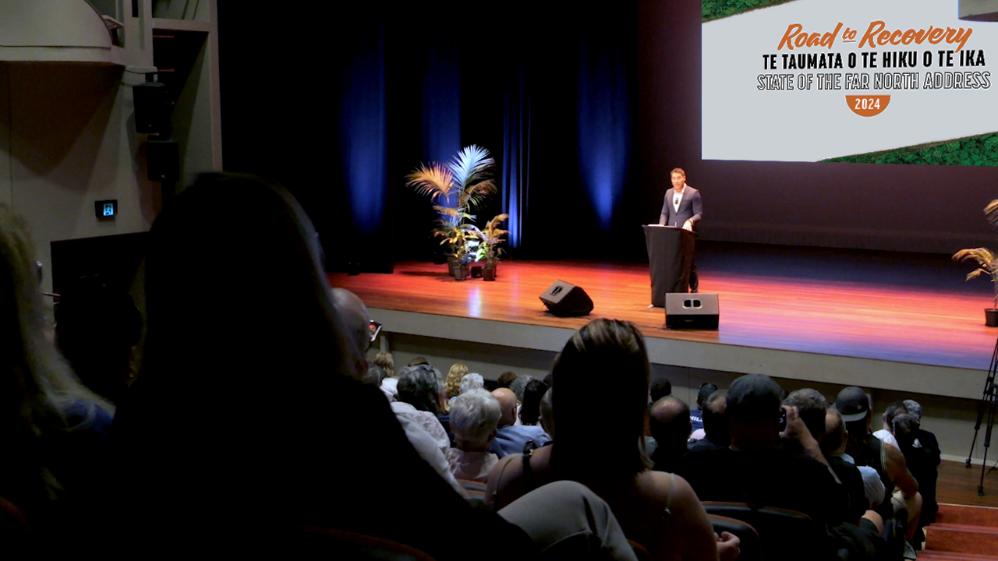
The address was crafted to maximise engagement, transparency, and relationship-building. It was designed to be an engaging platform with key messages clearly articulated and reinforced
The focus was on in-person attendance to enhance face-to-face interactions. RSVPs were required so tickets ensured key stakeholders were successfully targeted. The presentation was filmed and packaged for digital distribution to reach a broader audience after the event. By making the full presentation and highlights available on the council’s online platforms, the event reach extended to a wide audience and encouraged continued engagement and discussion.
The event was visually engaging, combining slides, videos, and live narration. These elements reinforced key messages and made complex topics easily digestible to a wide audience. Video segments showcased community members discussing council initiatives, making the content relatable and credible.
Messaging followed a three-phase approach:
- Reflecting on the past: Acknowledging the challenges faced, including the impacts of extreme weather, infrastructure challenges, and financial constraints.
- Showcasing progress: Highlighting actions taken, projects underway, and partnerships formed to address challenges.
- Looking ahead: Outlining plans for sustainable growth, community engagement, and infrastructure development.
A key component of the strategy was fostering two-way engagement. Networking opportunities allowed attendees to discuss the content, share perspectives, and build relationships with council representatives and fellow stakeholders. This informal setting encouraged open conversations and strengthened a sense of collective responsibility in shaping the district’s future. By creating an environment where attendees could interact freely, the event reinforced the council’s commitment to collaboration, transparency and engagement after the presentation.
Media played a vital role in ensuring messages from the presentation reached the wider community with journalists given direct access to the mayor and elected officials. By leveraging traditional and digital media, the council maximised the impact, ensuring key messages reached audiences beyond those in the room.
Project Success
The situation: Data from quarterly council resident satisfaction surveys reinforced the need for a new communication approach. In 2022, only 26% of residents expressed satisfaction with council’s performance, a figure that fell further to 18% by 2024. This decline signalled a growing disconnect between council and the community, requiring a shift towards more direct engagement. Additionally, negative perceptions surrounding roading conditions and infrastructure investment were prevalent.
The State of the Far North Address was designed as a response to this decline, aiming to reshape public sentiment and demonstrate transparency in decision-making and service delivery. By presenting a clear, structured account of challenges and solutions, the event provided an opportunity to rebuild trust and encourage ongoing dialogue between council and residents.
Looking ahead, future iterations of the address will build on this momentum, incorporating more interactive elements, expanding regional accessibility through roadshows, and further refining digital outreach strategies to engage an even wider audience.
Success criteria: The success of the State of the Far North Address was measured through multiple data points, including post-event surveys, media coverage, social media engagement, and audience reach.
Feedback from attendees was overwhelmingly positive, with post-event surveys indicating that 87% of respondents felt more informed about council’s priorities, and 82% stated they were more confident in the council’s approach to governance. Comments highlighted the effectiveness of the multimedia presentation and the mayor’s engaging delivery, reinforcing the need for continued face-to-face interactions between local government and the community.
Media coverage played a significant role in extending the reach of the event’s messages. RNZ described the address as “a groundbreaking approach to local government transparency”, while NZ Herald reported that the event “set a new precedent for community engagement in New Zealand”. Te Ao News highlighted the event’s emphasis on Te Ao Māori partnerships, noting that “the integration of tikanga throughout the address demonstrated a commitment to genuine collaboration”.
From a digital engagement perspective, the full event video received over 430 views and nearly 100 hours of watch time within the first two weeks. Its impact has continued to grow beyond the initial broadcast, as updates on council projects link back to key insights from the address. By the three-month mark, cumulative watch time had surpassed 250 hours, demonstrating the ongoing relevance of the event as a cornerstone communication tool. Social media engagement also saw a substantial boost, with a 46% increase in video shares and 20,000+ post impressions across council’s platforms.
Of significance was a near doubling in the overall reputation rating for the council in the quarterly resident satisfaction survey - from 17 to 30% compared to the previous year. Roading was a key message in the Road to Recovery themed address. Satisfaction with this measure increased from an all-time low of 8 % in 2024 to 18% in the latest 2025 results.
Barriers traversed: The State of the Far North Address was unprecedented in New Zealand local government, demonstrating bold leadership, innovation, and a commitment to transparency. Community and Engagement Group Manager Ruben Garcia had experience with similar State of the Nation-style presentations in the United States and his guidance was invaluable. However, it was unknown how well this concept would translate in the New Zealand context or how inclined the Far North’s diverse and disparate communities would be to attend a mid-week, evening event. On the night, the event exceeded expectations garnering praise from its 200-plus guests, many of whom travelled for an hour or more to attend (some from as far away as Auckland), media coverage also hailed the event for its innovation and transparency.
Business-as-usual: A post-event content strategy ensured ongoing engagement, with full recordings and highlights made available on YouTube and social media. Journalists had direct access to the mayor and elected officials at the event after the address, facilitating accurate reporting.
As promised by Mayor Tepania during the State of the Far North Address, updates on projects in the following weeks and months were published by the council. These included a new water supply for Kaitāia, the transfer of Kaitāia Airport’s ownership to iwi and hāpu, the design of new library for Kaikohe, and the transformation of Kerikeri’s Procter Library into a multi-service space. Even now, months later, council media releases continue to include links back to the State of the Far North Address video, demonstrating how well the topics covered in the address resonated with our audiences.
The intention is for the State of the Far North Address to become an annual part of the council’s events calendar with future addresses building on the momentum created by the Road to Recovery-themed event.
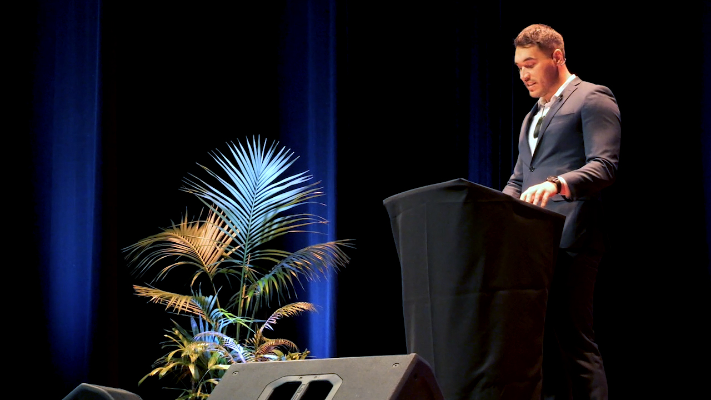
Lessons: From a public relations perspective, the address aimed to reshape negative perceptions by creating an essential, recurring event that could build credibility and public trust over time. The key objectives were to establish a direct and transparent means of engagement with the community, ensuring that the council’s efforts were effectively communicated. Another goal was to ‘open the books’ to move key influencers from a position of dissatisfaction with infrastructure and services to a broader, solutions-focused perspective.
The event aimed to ensure that at least 80% of attendees left with a clearer understanding of council’s plans and projects, as assessed through post-event surveys. Providing clear, data-driven updates on financial management, infrastructure progress, and community development initiatives was crucial to this objective. The event also aimed to directly address public concerns and outline concrete actions taken to resolve them, demonstrating council’s commitment to responsiveness and transparency.. Finally, the State of the Far North Address was intended to be integrated into council’s annual engagement strategy, ensuring that this level of dialogue with residents would continue and evolve in the years ahead.
The mayor issued a clear call to action, urging residents to participate in council consultations, submit feedback on major initiatives, and to take an active role in the democratic process.
The in-person turnout clearly demonstrated that many within our communities want to know more about the activities of the council and are prepared to go out of their way to access that information. This underlines that the negative attitudes often visible on social media platforms does not represent the views of the everyone.
The State of the Far North Address proved that many residents have an appetite to understand the decisions of council and will respond positively when information is presented in an open, relatable, and accountable way.
Any local authority could undertake this type of presentation - something this council would support – as an increase in civic engagement is of benefit all local authorities.
The State of the Far North Address was achieved almost entirely using in-house resources. In the midst of a cost-of-living crisis, we were acutely aware of possible criticism over costs. There were none.
Undoubtedly Mayor Moko Tepania’s confidence as a presenter was a key factor in getting the tone right. That is critical and requires the script to be workshopped thoroughly. A presentation that ‘misreads the room’ could significantly damage reputation.
The success of getting this event right was evident in the significant improvement in public sentiment, increased engagement, and the strengthened sense of partnership between council and the community.

